SSH AND SCP AUTHETNICATION WITH PUBLIC AND PRIVATE KEY
Author: John Ballén

1. GENERATE PRIVATE AND PUBLIC KEY – LOCAL SERVER

You can create the keys with command:

$ssh-keygen

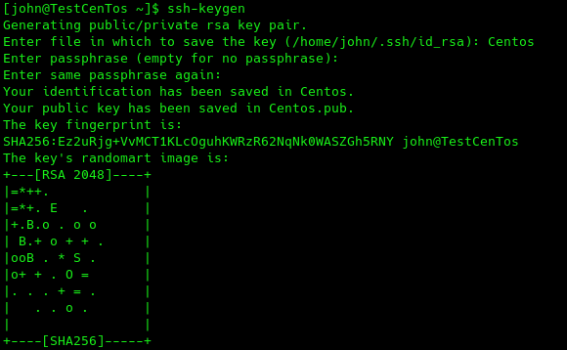

two files will be generated, the private key and the public key in ".ssh" in the user home folder. In some operative systems the keys are generated in the folder where you execute the program.

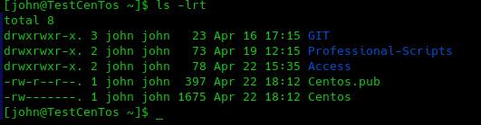

In this case the keys are named Centos.

2. CONFIGURE KEYS – REMOTE SERVER

From your local server, hit the following command:

ssh-copy-id -i ~/’file pub location’ user@192.168.0.x

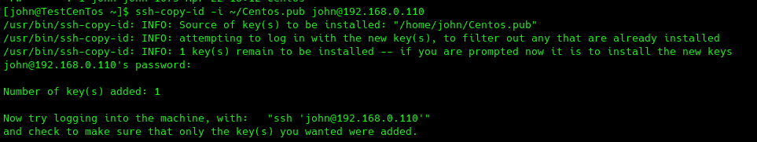

After that, the program asks you for the password and this will indicate that you added 1 key. The next time that you try to enter to a remote server, this not will ask you for a password.

